Assignment no 1

Aniket Dharmik

U01337758

Q1. What is GitHub? When was it created? Why? By who? What similar platforms exist? Why would you use such a platform?

Answer:

GitHub is a repository hosting service. It acts as a cloud for the code. GitHub will host source code projects in a variety of different programming languages and keep track of the various changes made to every code. GitHub lets user to work on projects from anywhere.

GitHub development started in October 2007 and it was launched in April 2008 by Tom Preston-Werner, Chris Wanstrath, and PJ Hyett.

After GitHub, Bitbucket is the most popular in terms of popularity and usage. Whereas there are many more similar to GitHub like GitLab, Kiln, Codeplane, CodePlex.

I use GitHub to save my code and documents and resume from anywhere whenever I wanted. It allows me to access my code remotely.

Q2. Define the following terms in the context of Git (2 lines maximum):

* Repository

Repository is used to organize a single project. It contains folders and files, images, videos, spreadsheets in it.

* Commit

A commit is a change to a file or set of files. It's like when you save a file, except with Git, every time you save it creates a unique ID that allows you to keep record of what changes were made when and by who. Commits usually contain a commit message which is a brief description of what changes were made.

* Push

Push refers to sending committed changes to a remote repository, such as a repository hosted on GitHub. For example, if we change something locally, and we want to then push those changes so that others may access them.

* Branch

A branch is a parallel version of a repository. It is contained within the repository, but does not affect the primary or master branch allowing you to work freely without disrupting the "live" version. When you've made the changes you want to make, you can merge your branch back into the master branch to publish your changes.

* Fork

A fork is a personal copy of another user's repository that lives on your account. Forks allow you to freely make changes to a project without affecting the original. Forks remain attached to the original, allowing you to submit a pull request to the original's author to update with your changes. You can also keep your fork up to date by pulling in updates from the original.

* Merge

Merging takes the changes from one branch and applies them into another. This often happens as a pull request or via the command line. A merge can be done automatically via a pull request via the GitHub web interface if there are no conflicting changes, or can always be done via the command line

* Clone

A clone is a copy of a repository that lives on your computer instead of on a website's server somewhere, or the act of making that copy. With your clone you can edit the files in your preferred editor and use Git to keep track of your changes without having to be online. It is, however, connected to the remote version so that changes can be synced between the two. You can push your local changes to the remote to keep them synced when you're online.

* Pull

Pull refers to when you are fetching in changes and merging them. For instance, if someone has edited the remote file you're both working on, you'll want to pull in those changes to your local copy so that it's up to date.

* Pull request

Pull requests are proposed changes to a repository submitted by a user and accepted or rejected by a repository's collaborators. Like issues, pull requests each have their own discussion forum.

Q3. GitHub tutorial

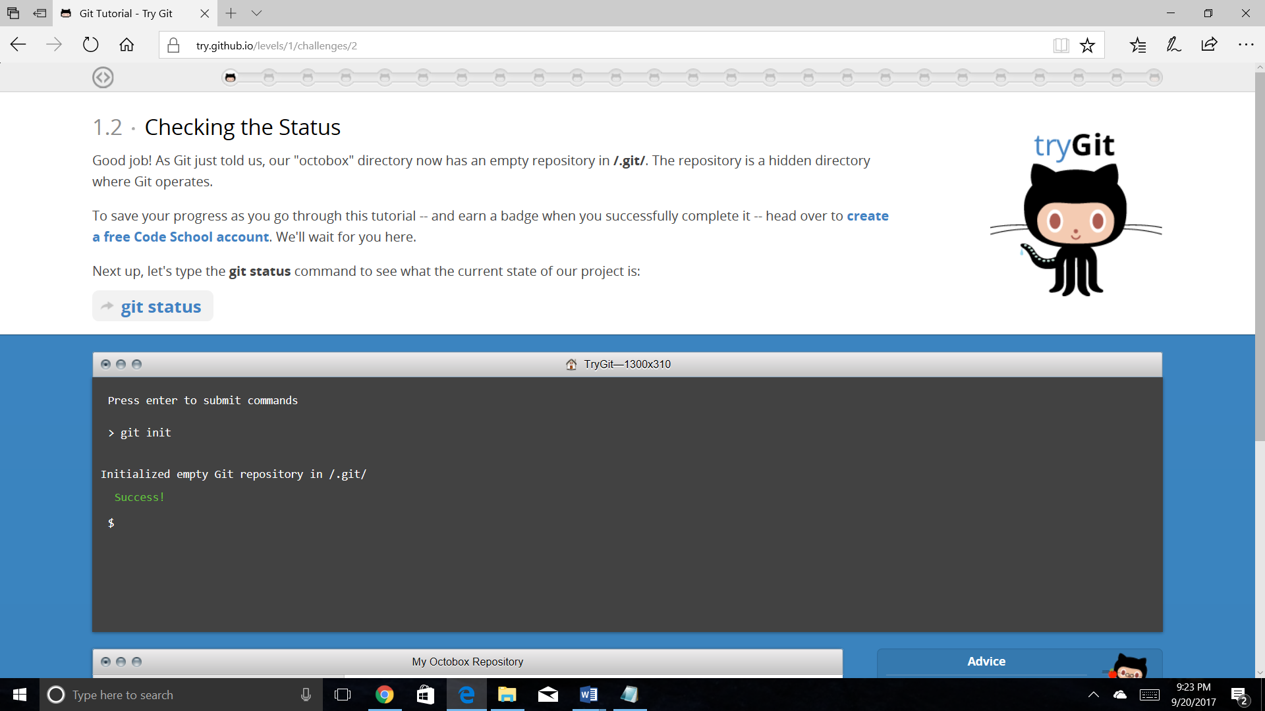

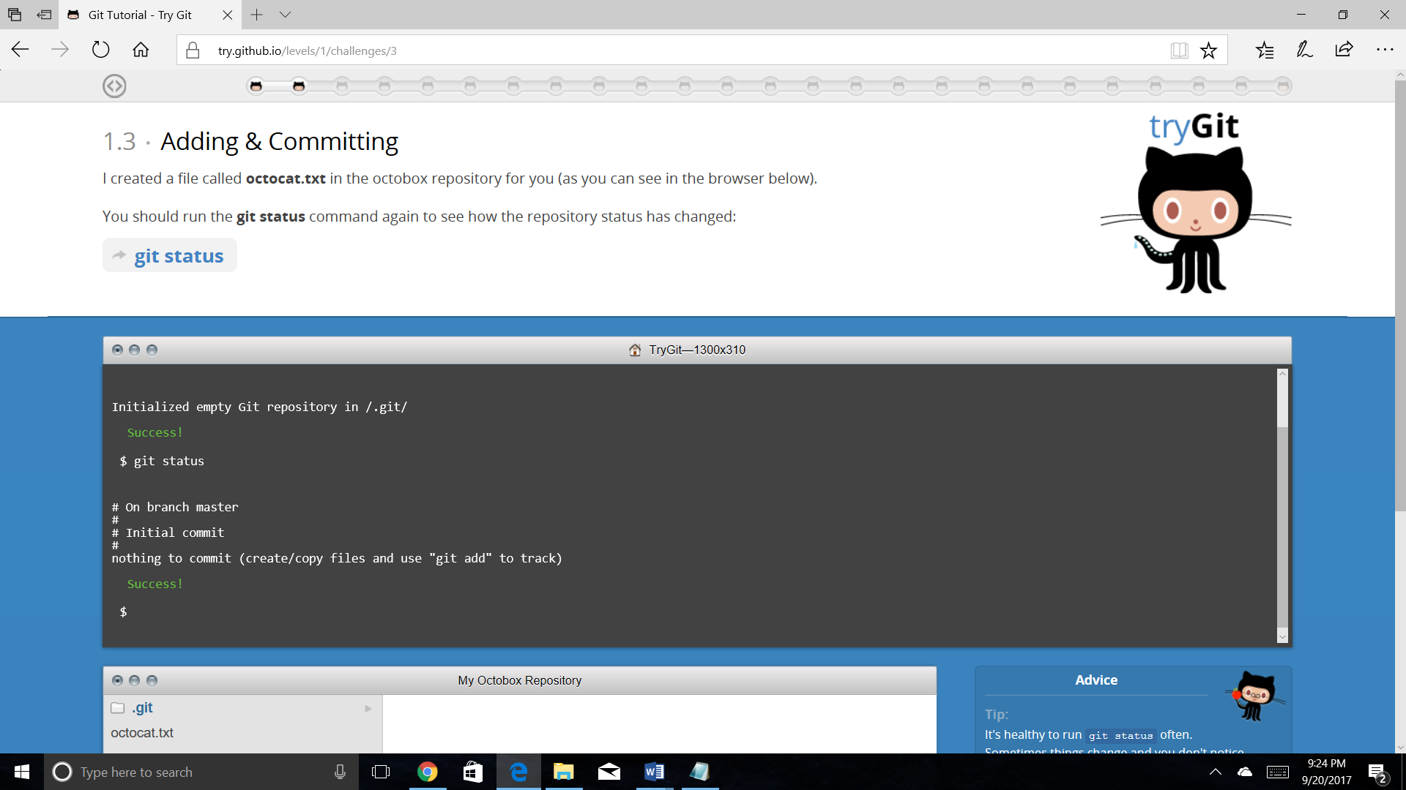

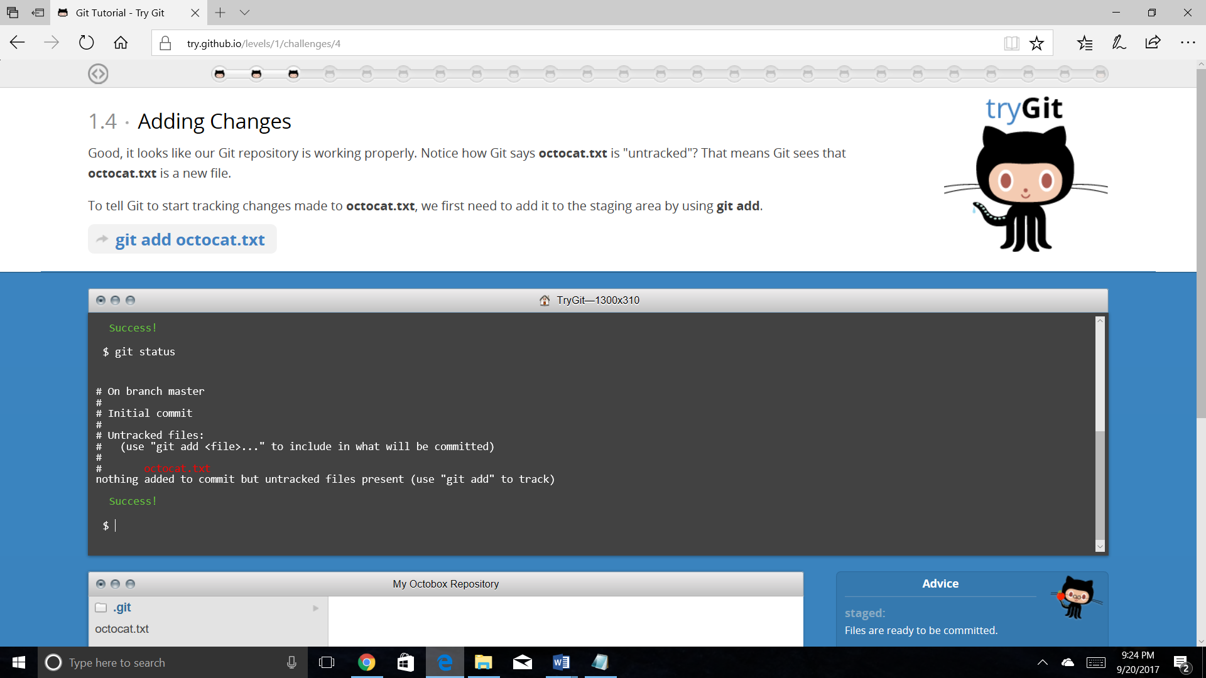

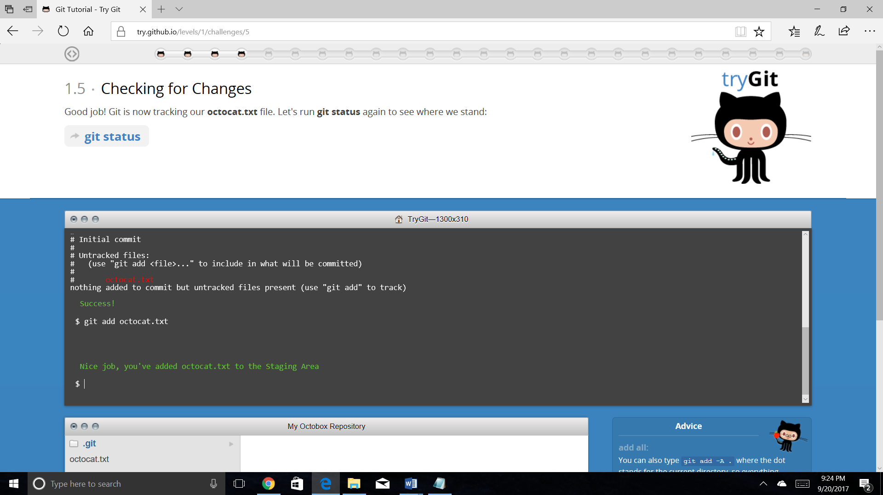

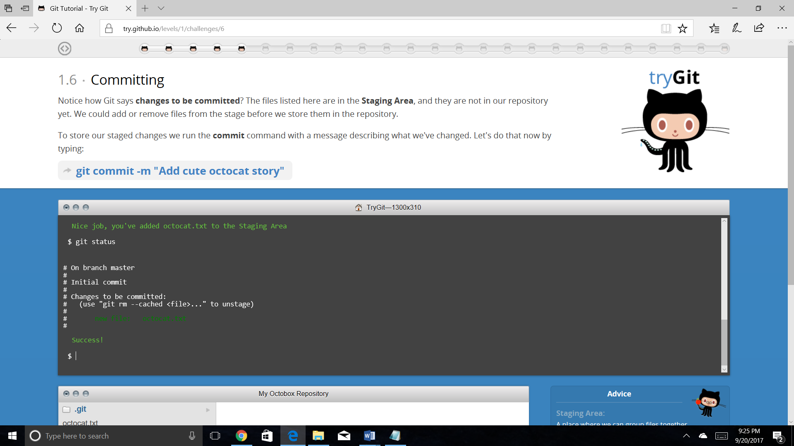

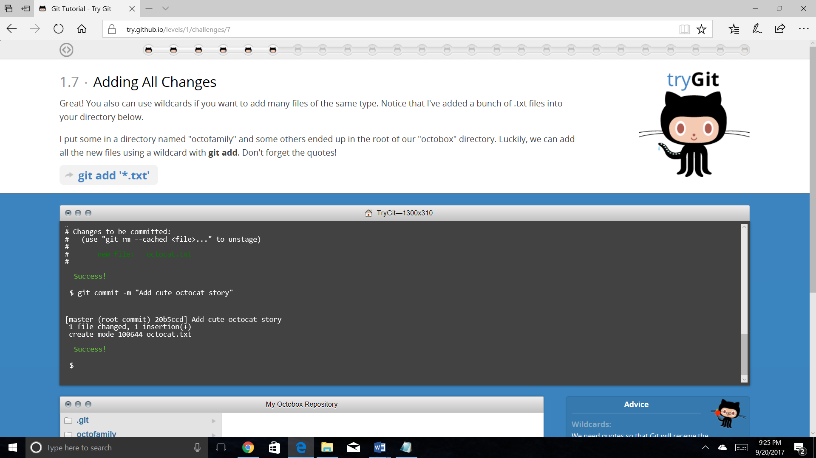

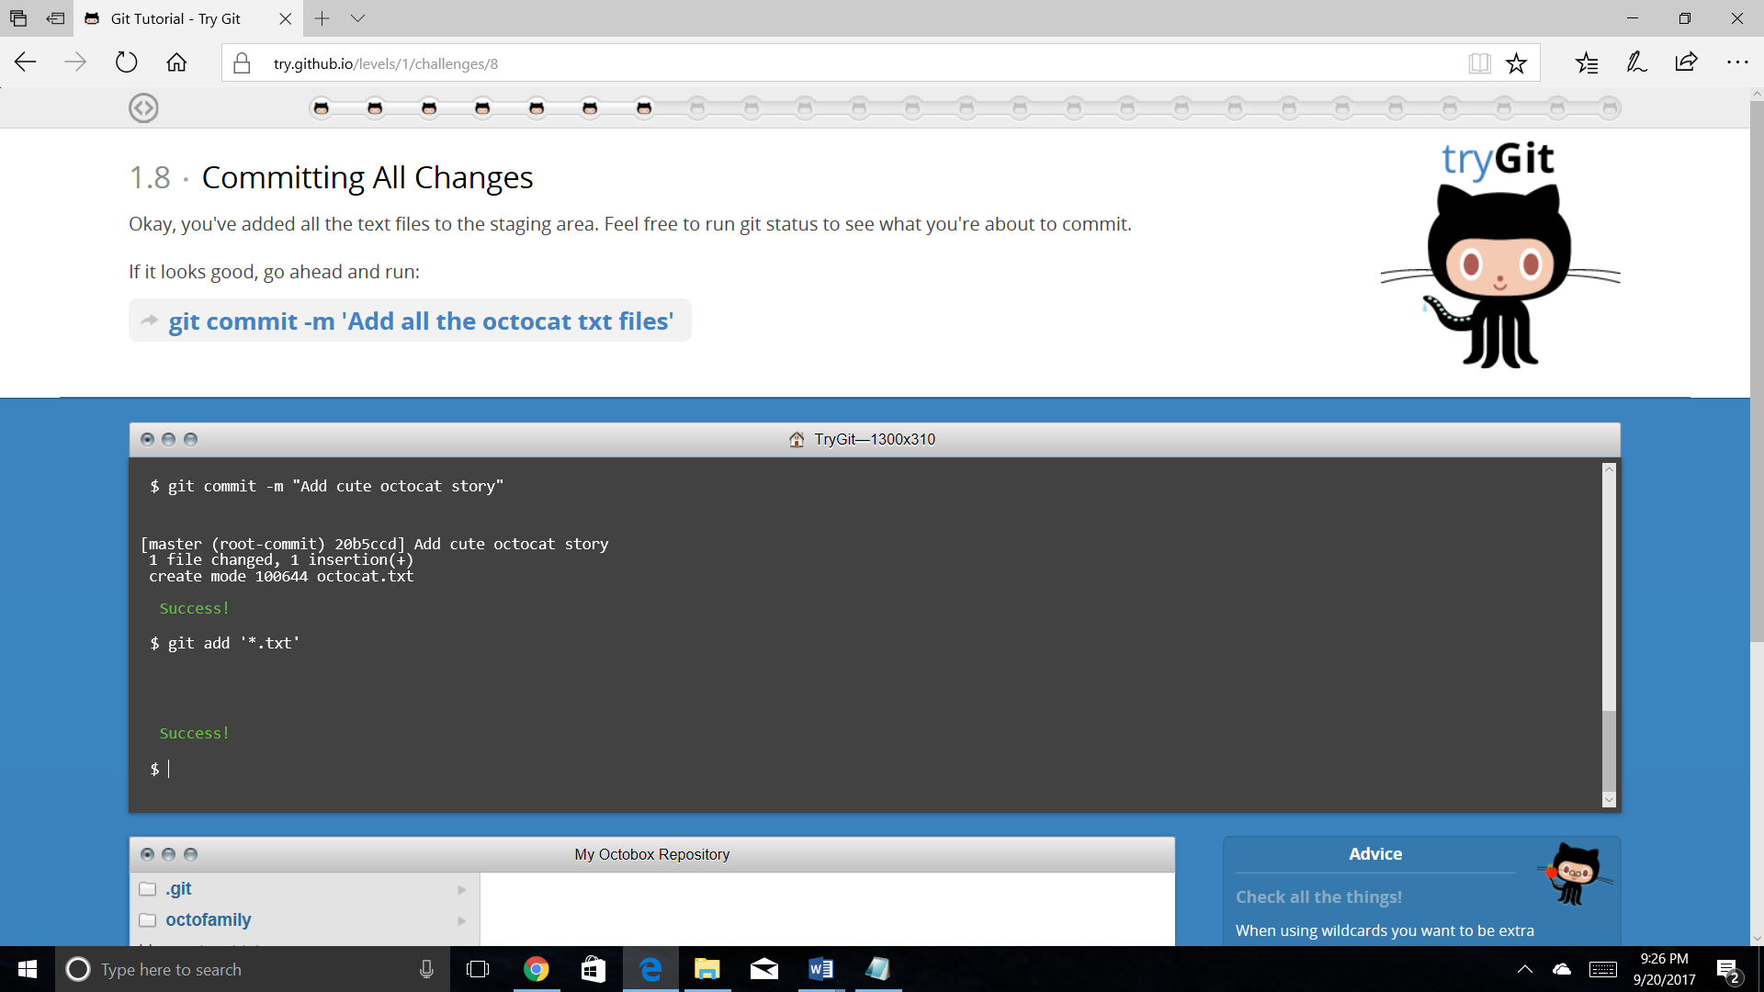

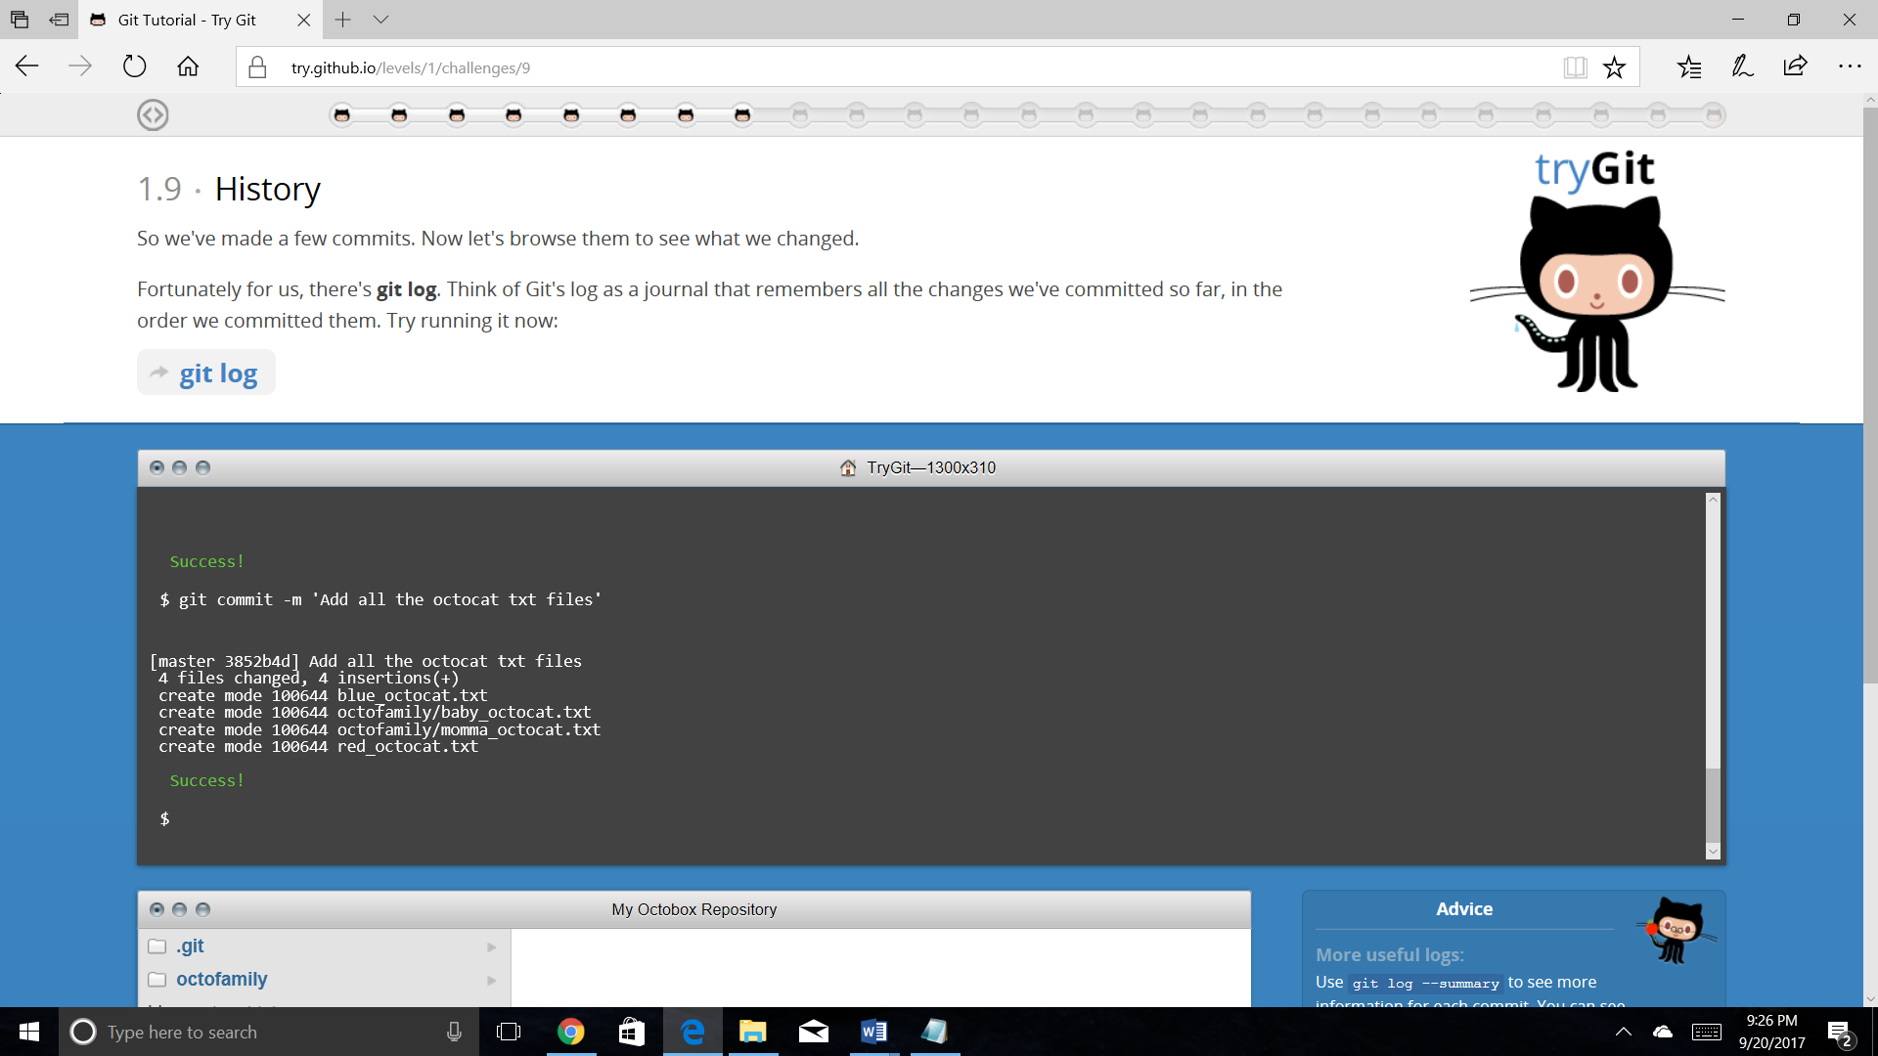

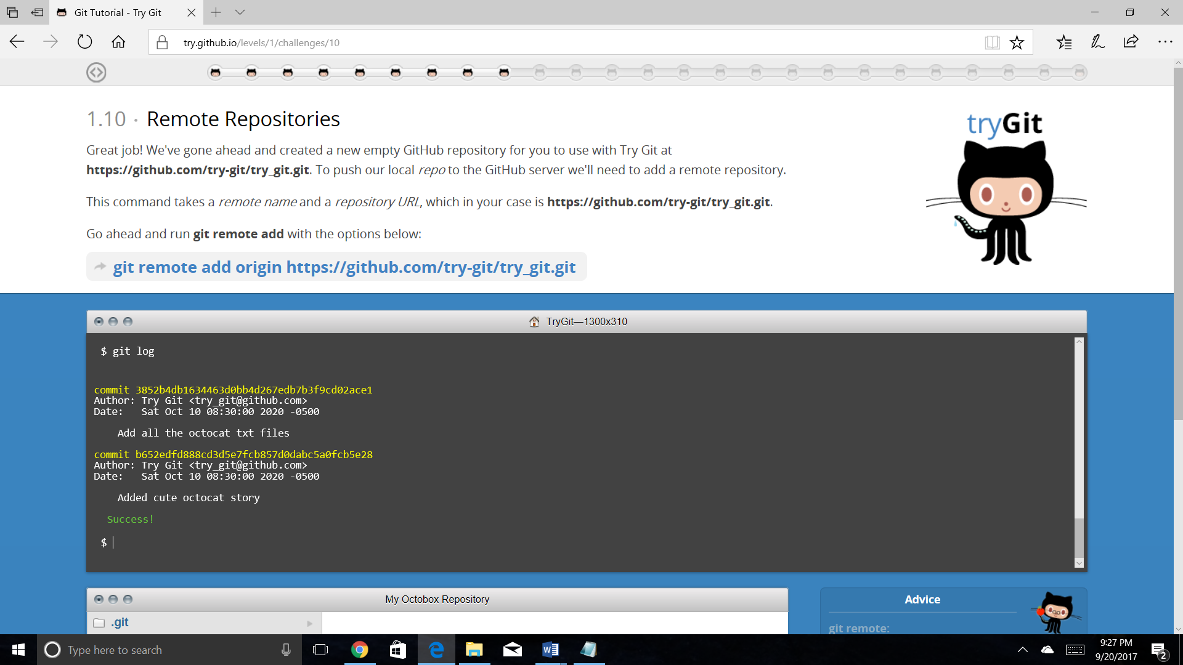

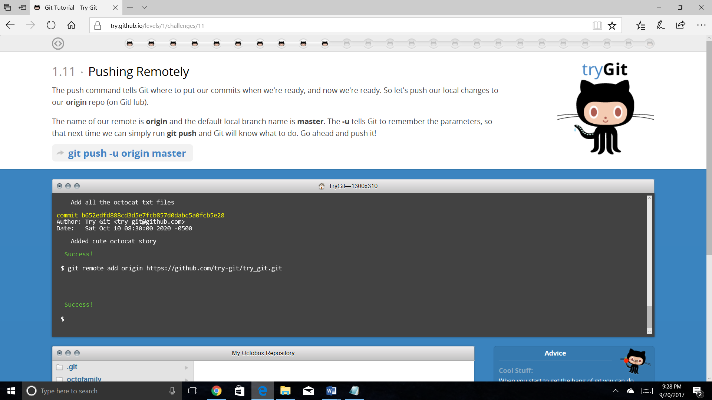

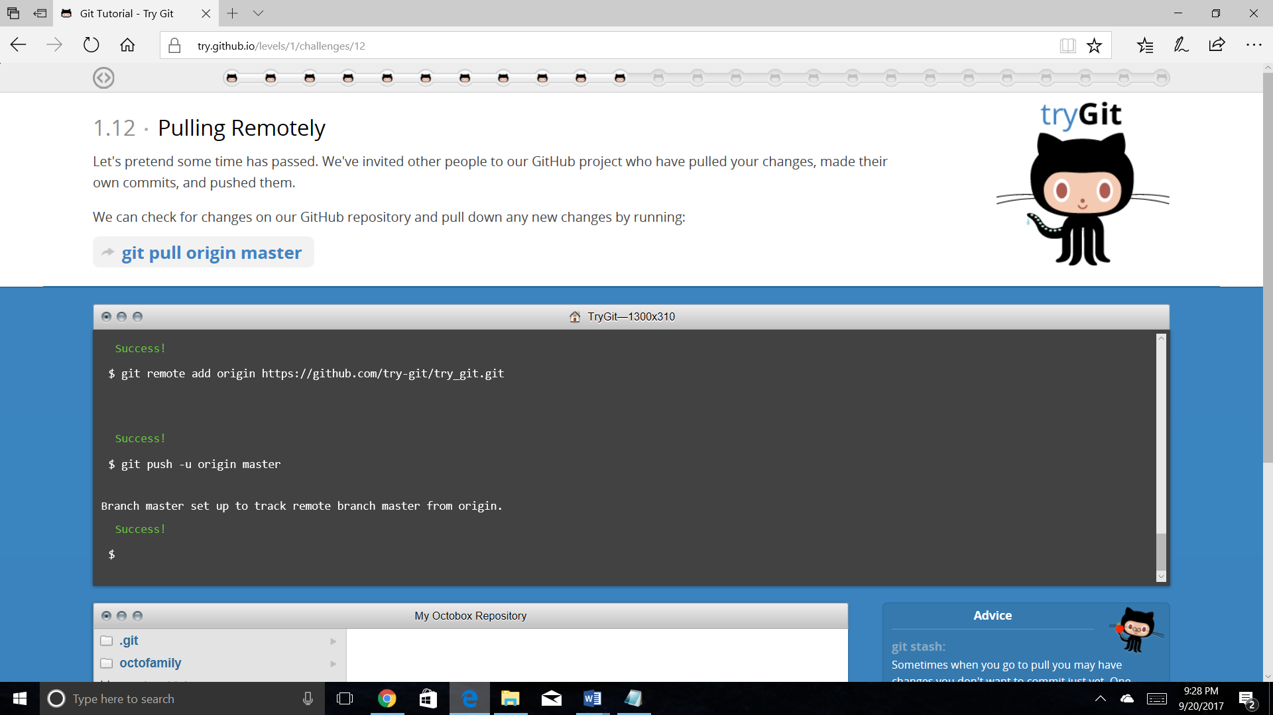

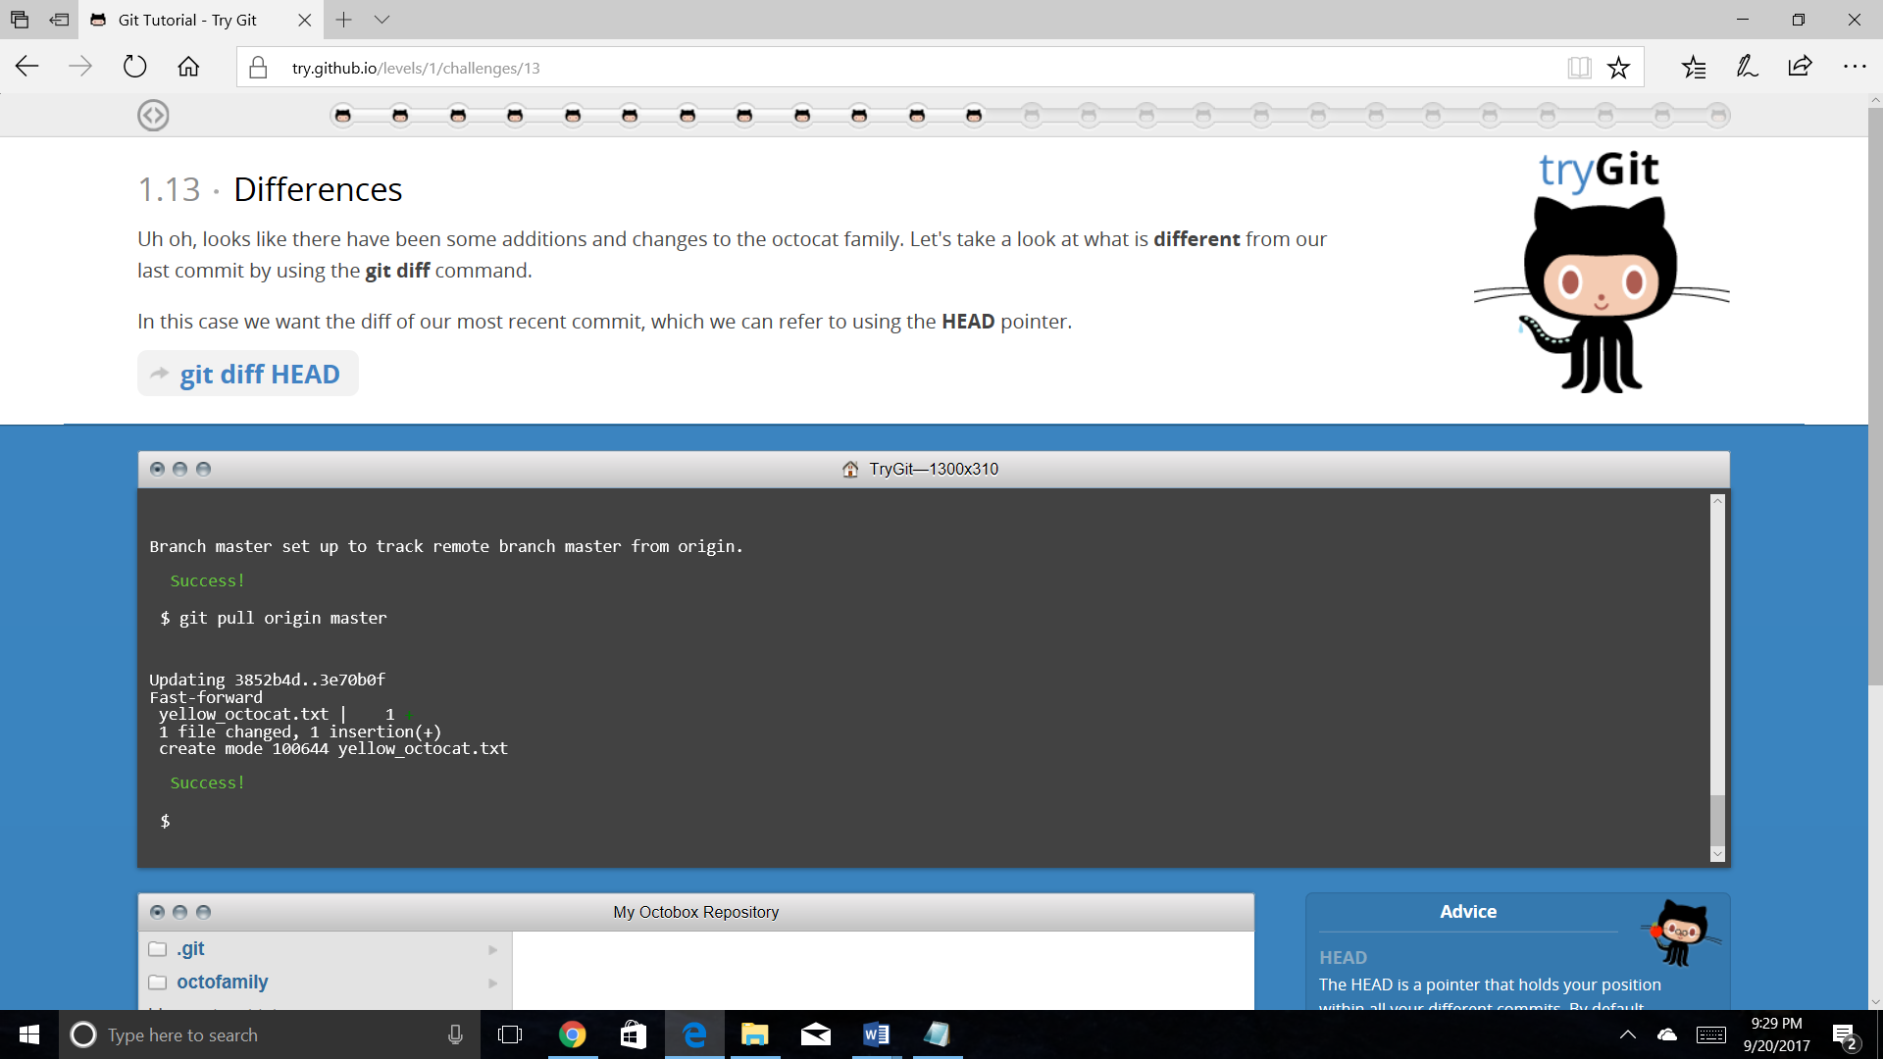

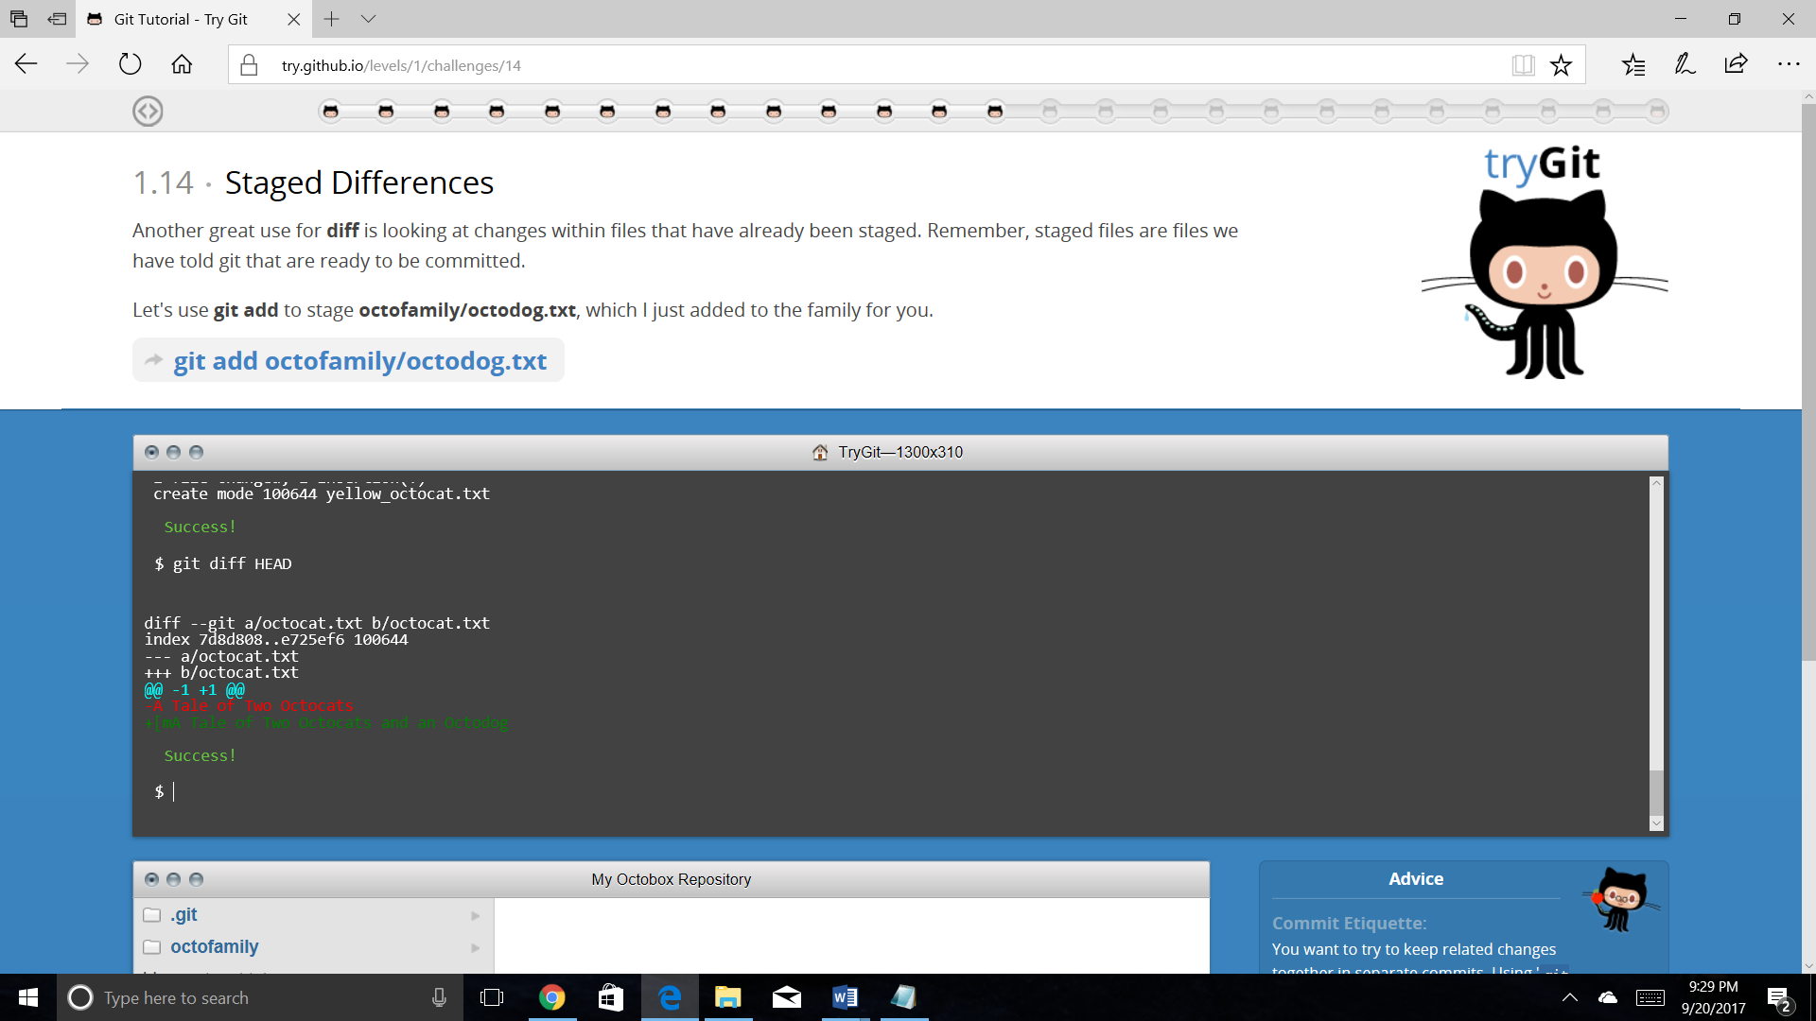

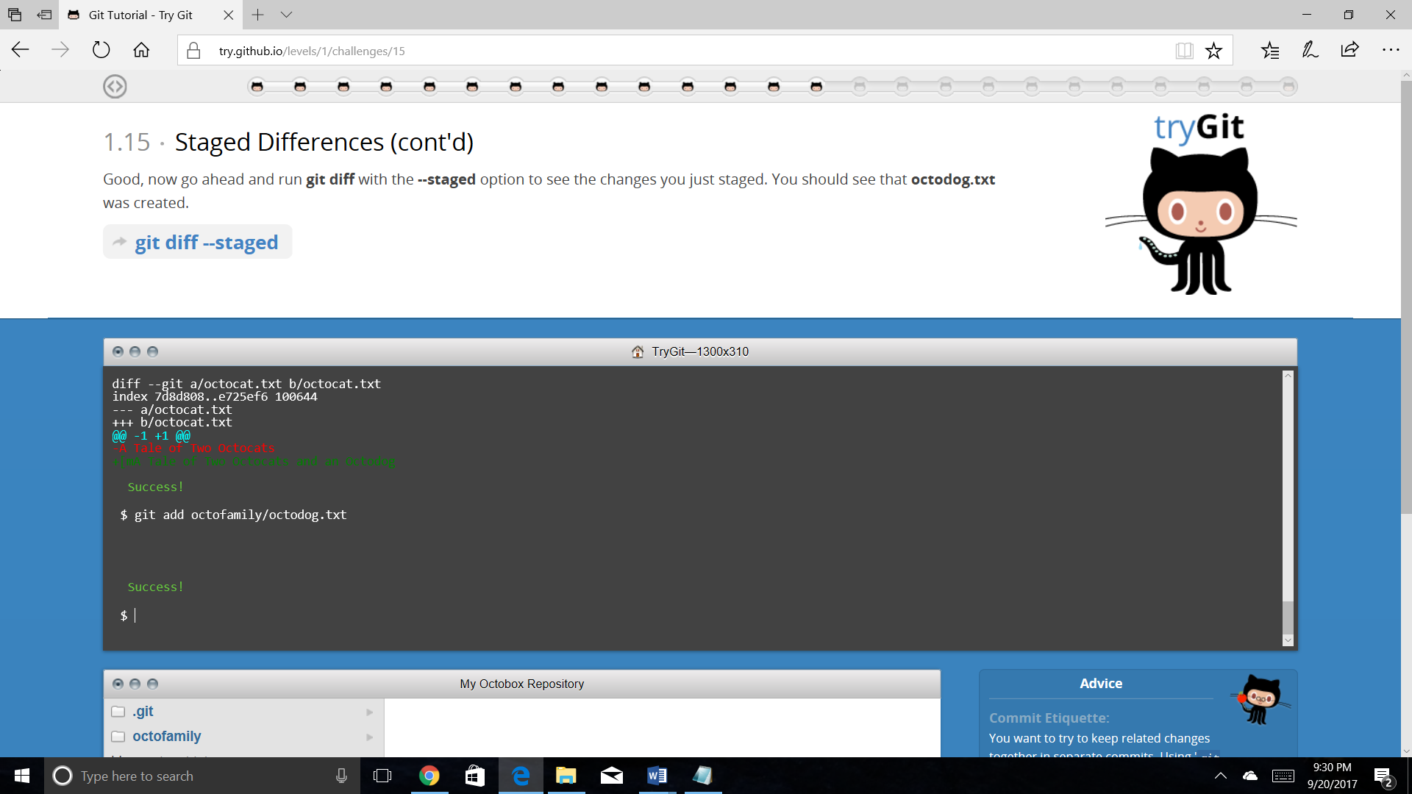

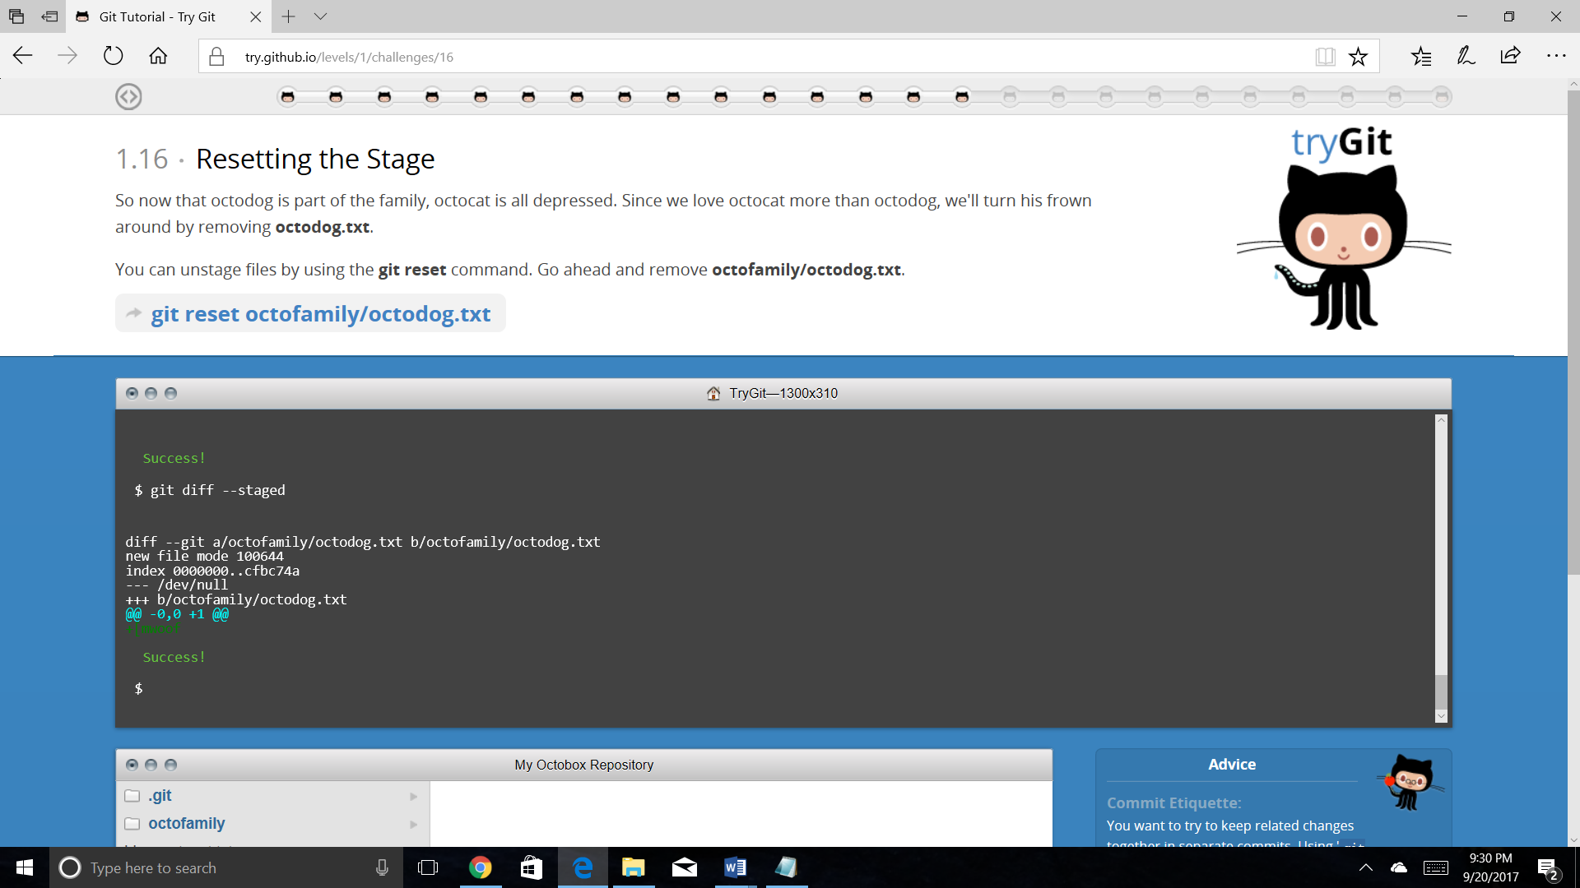

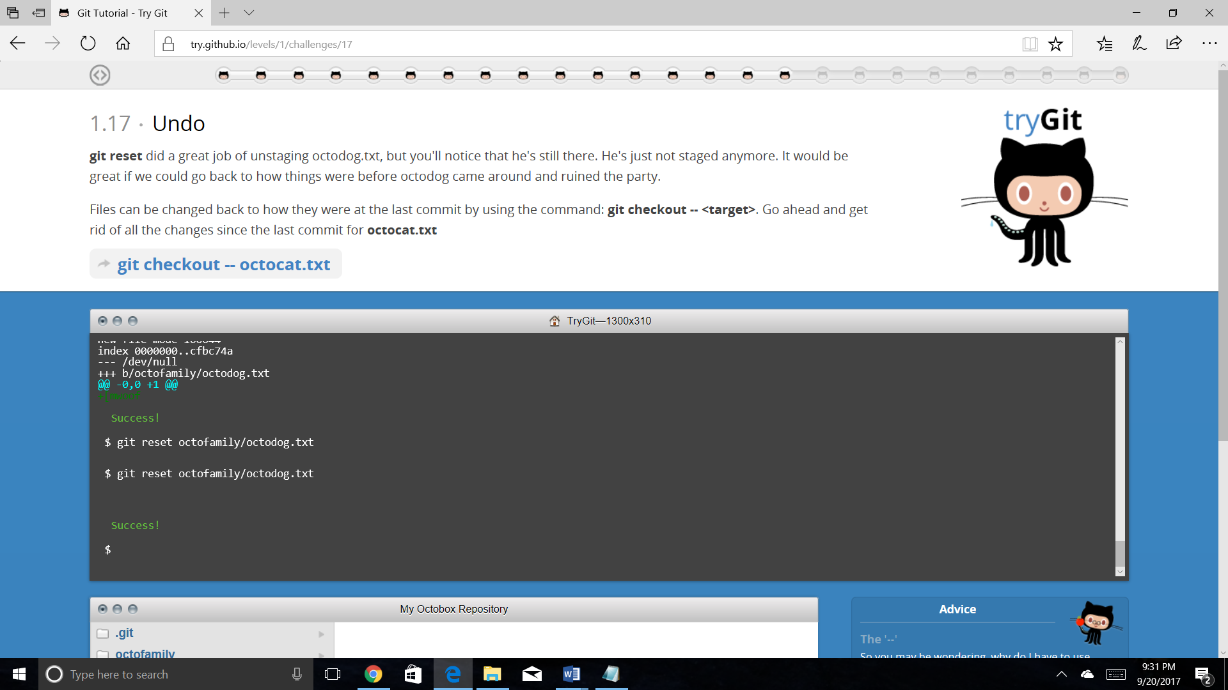

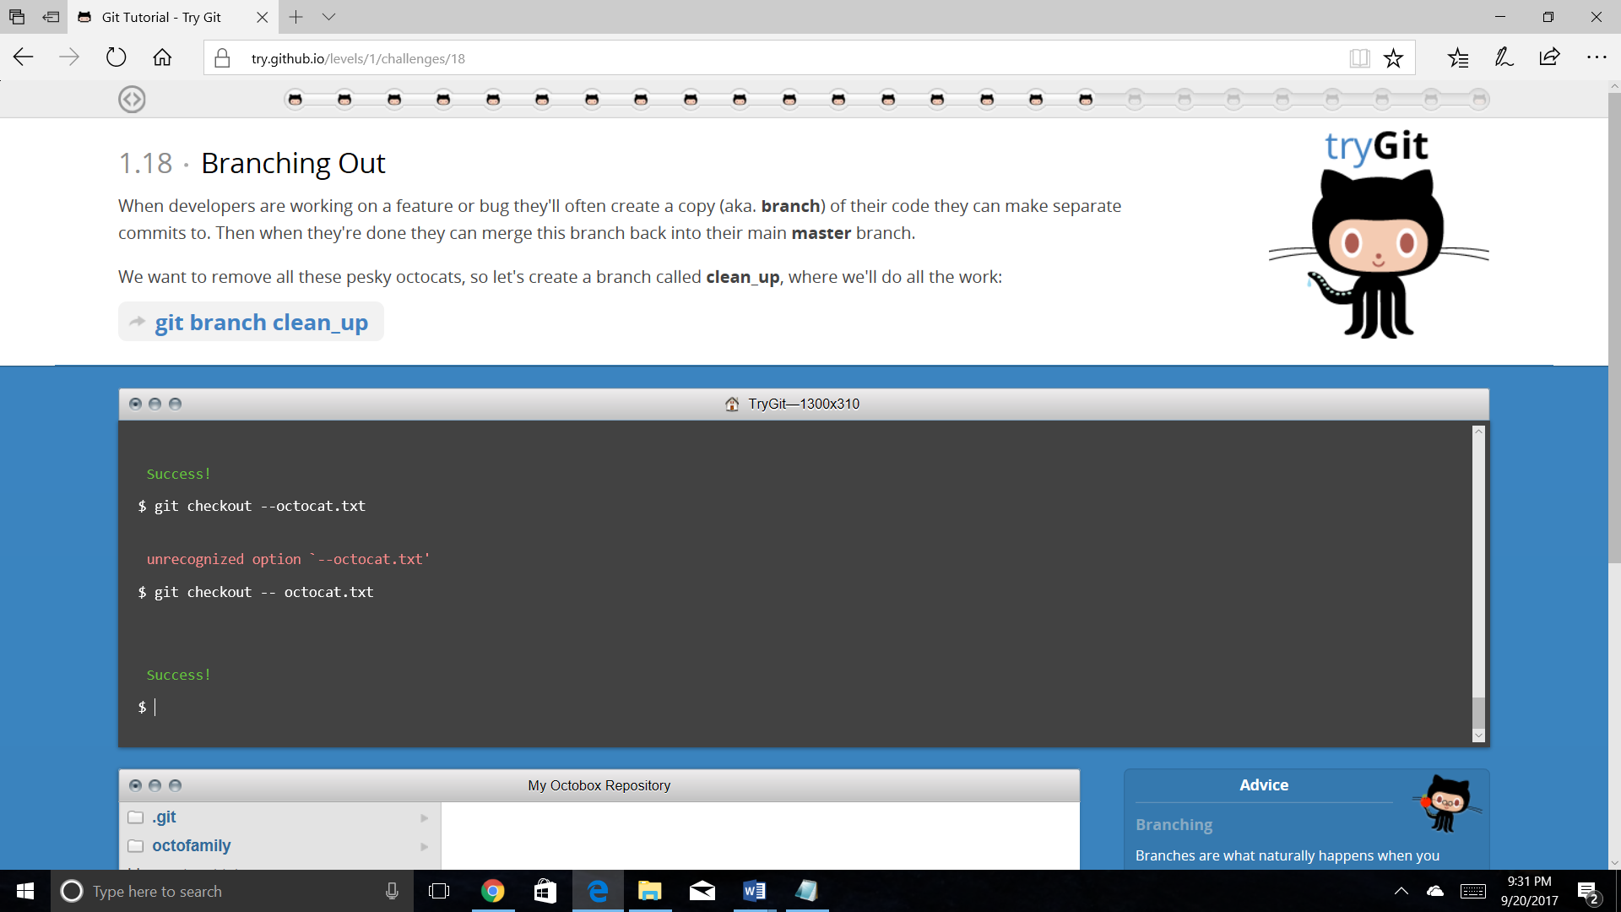

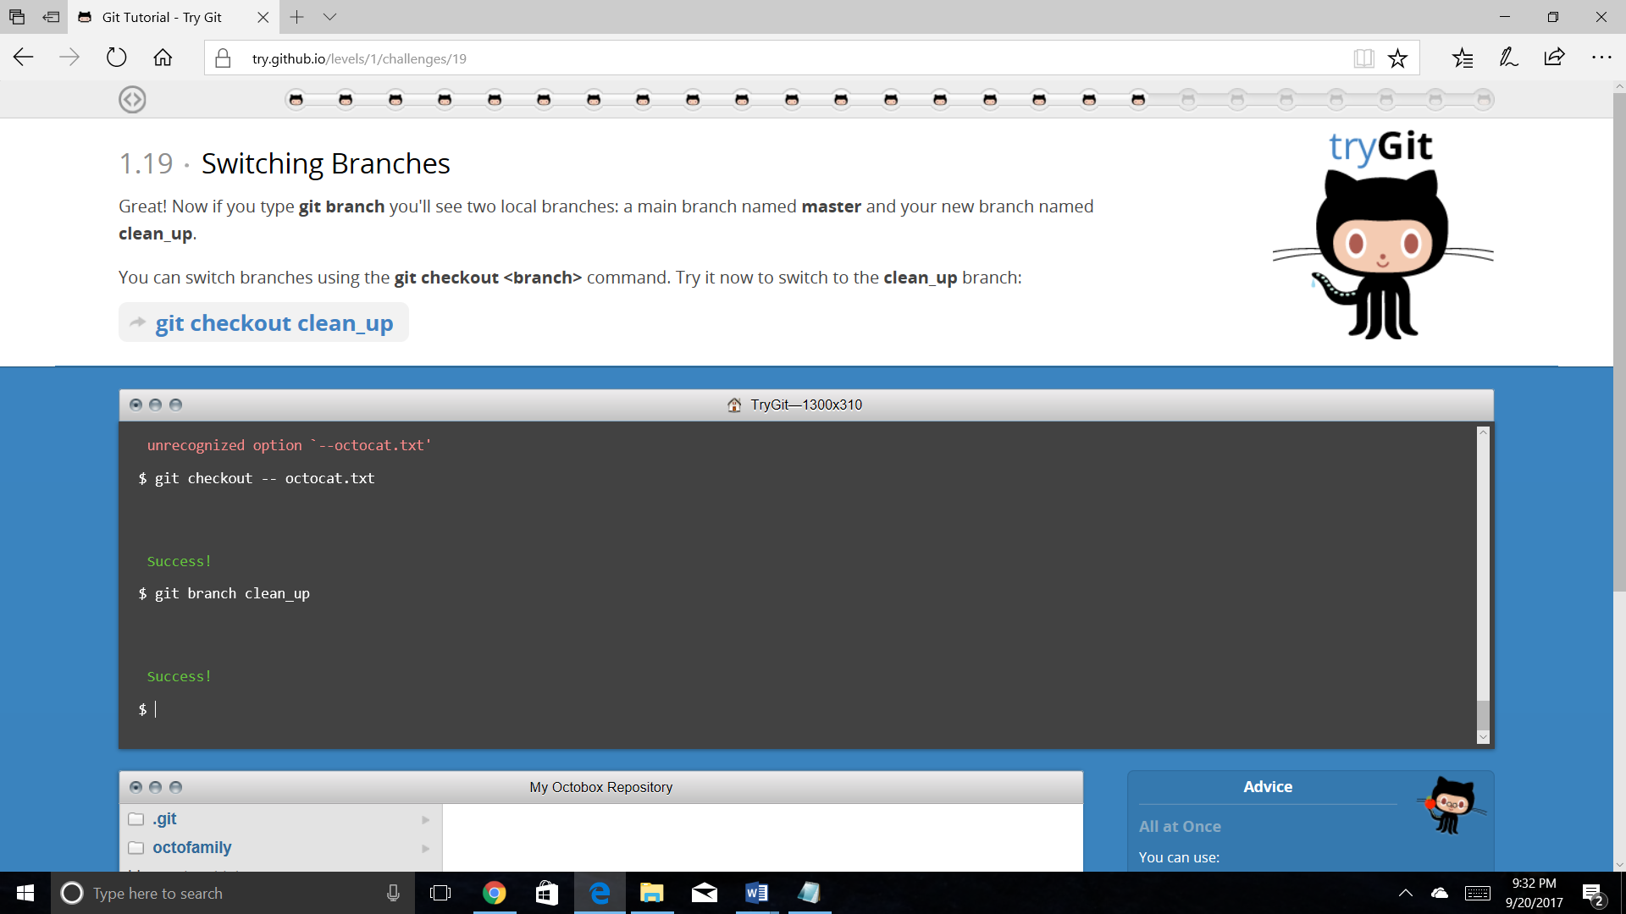

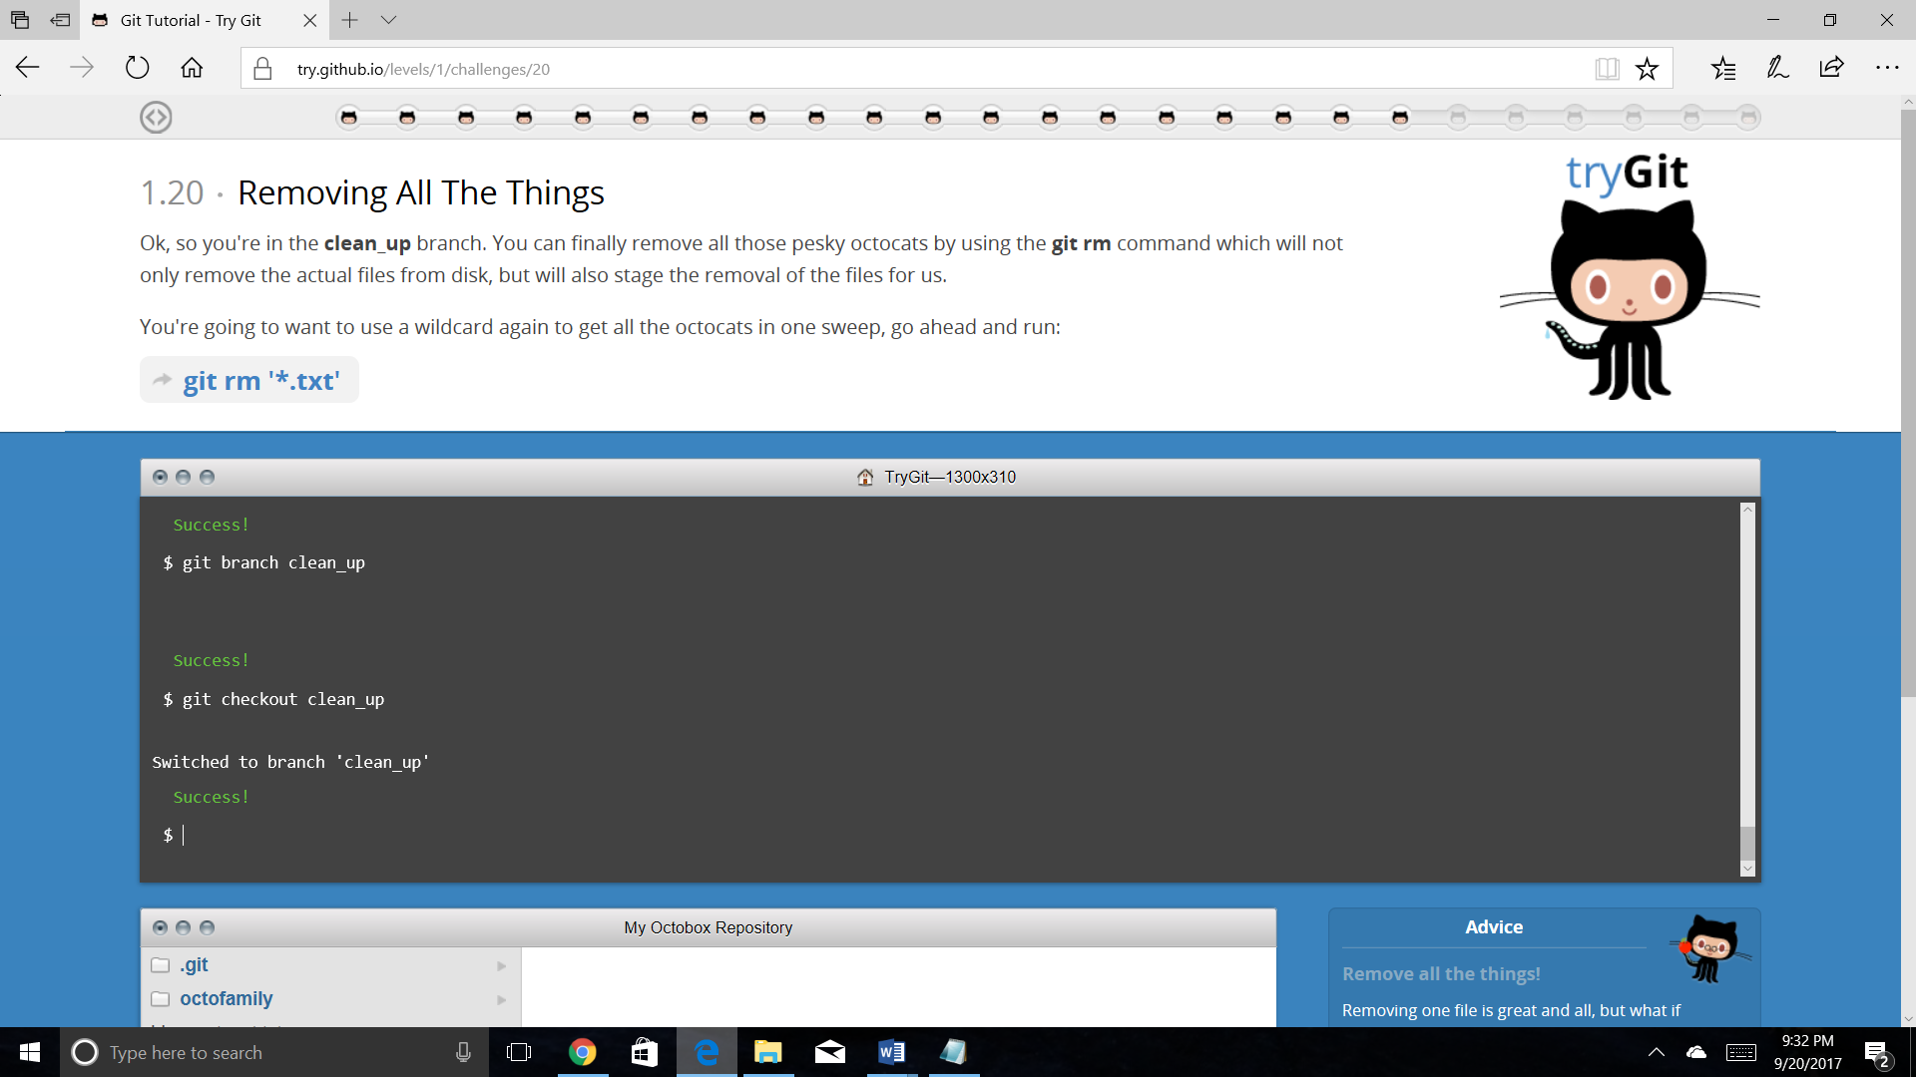

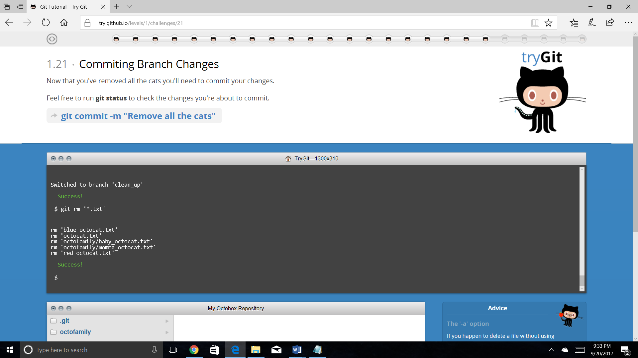

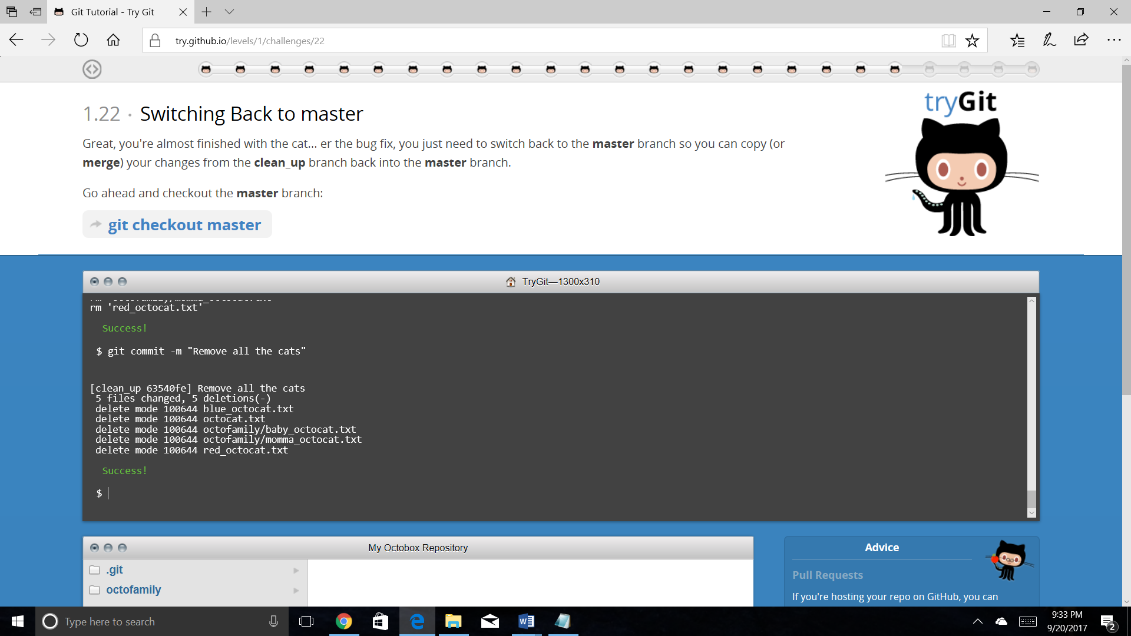

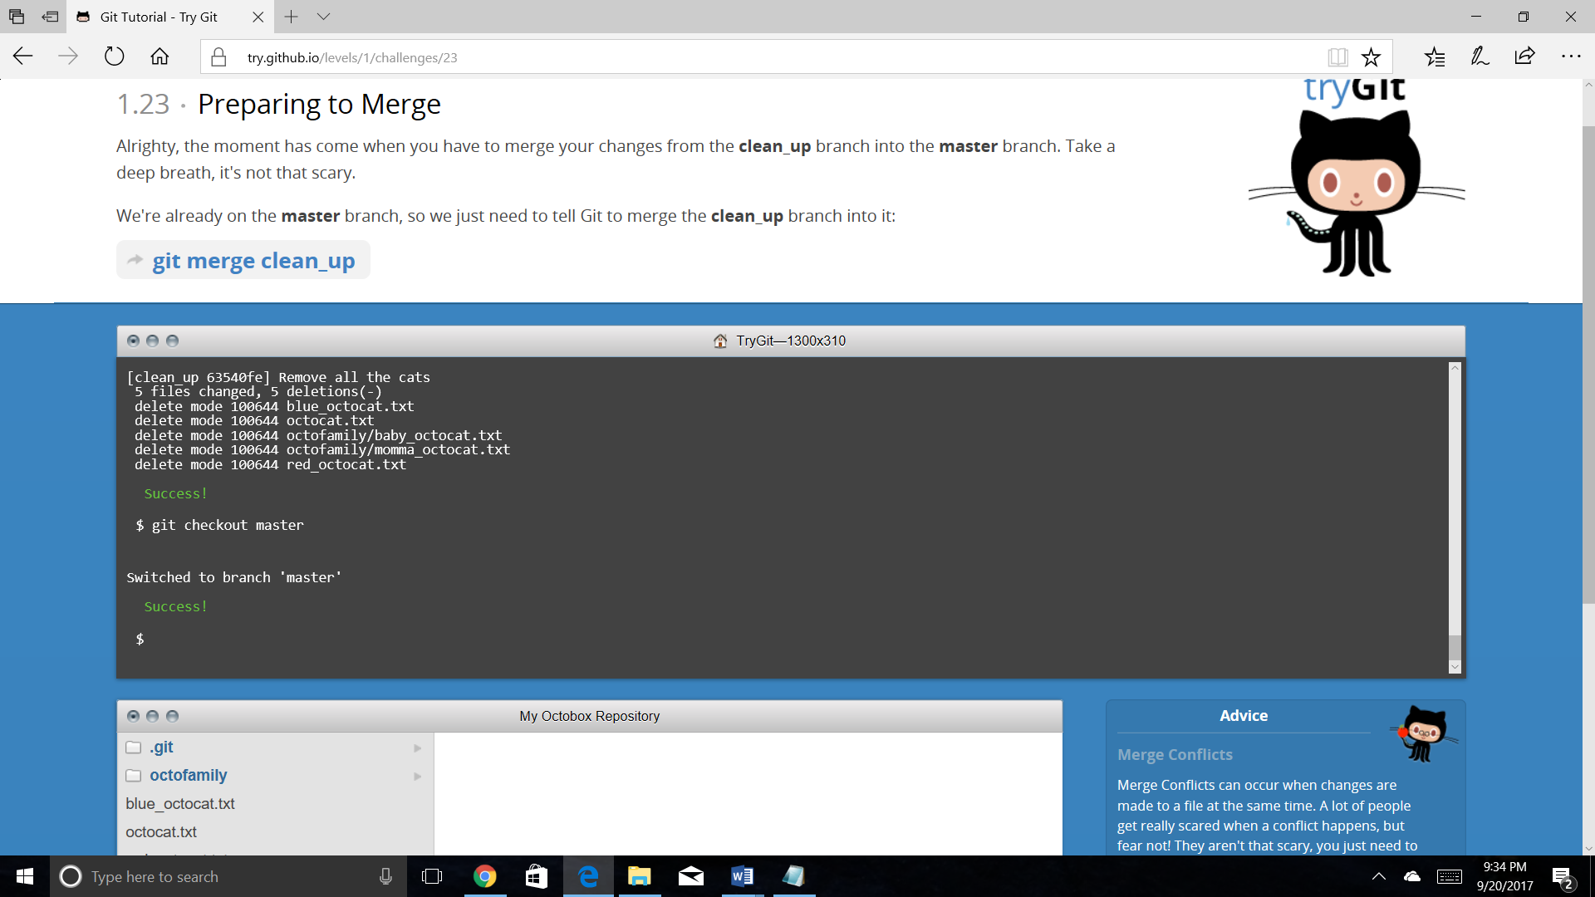

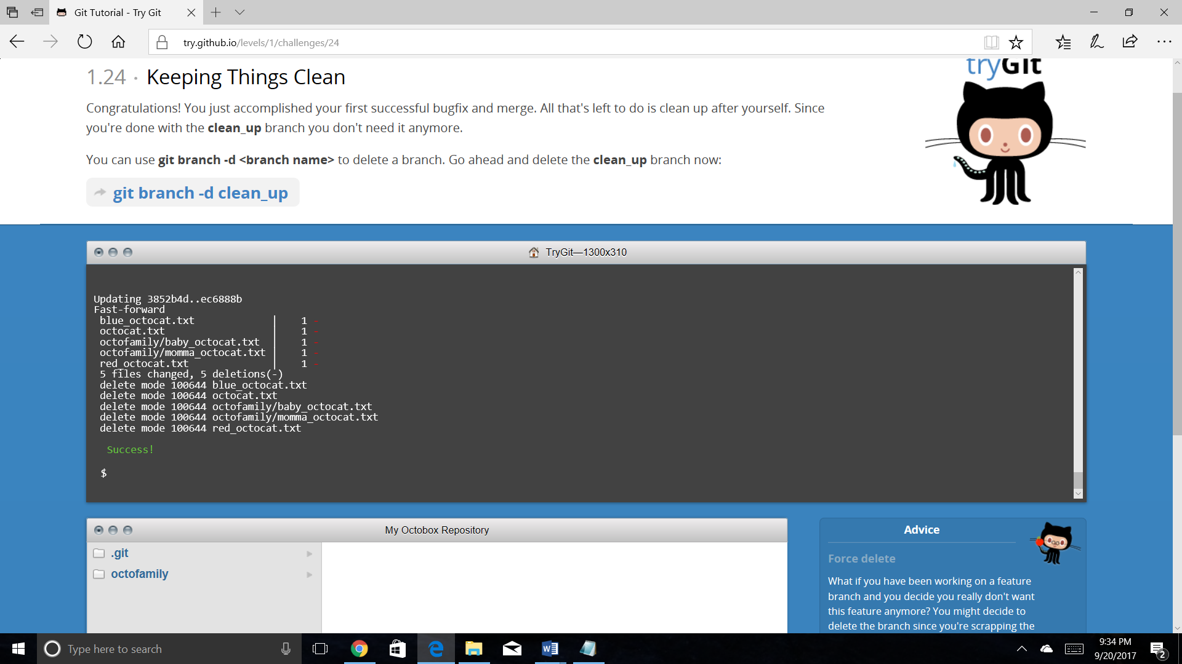

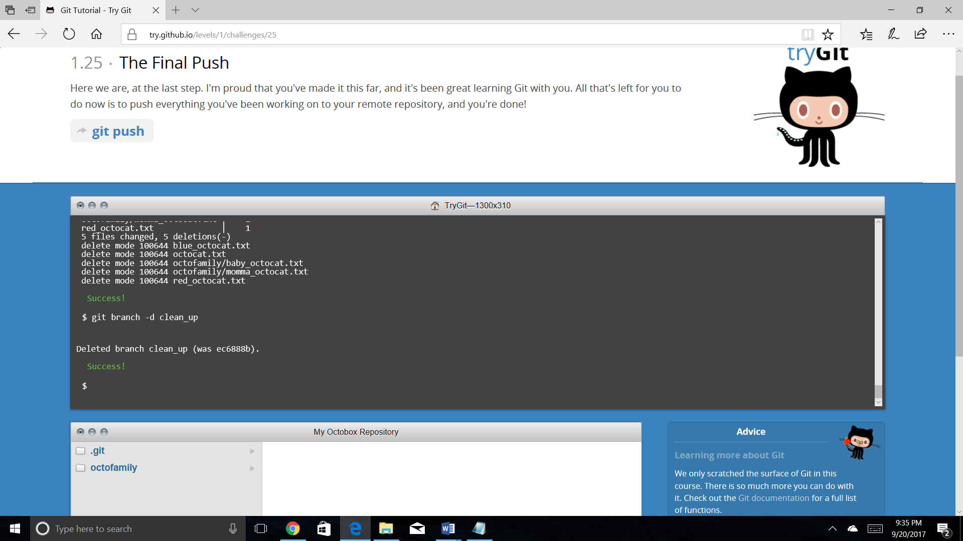

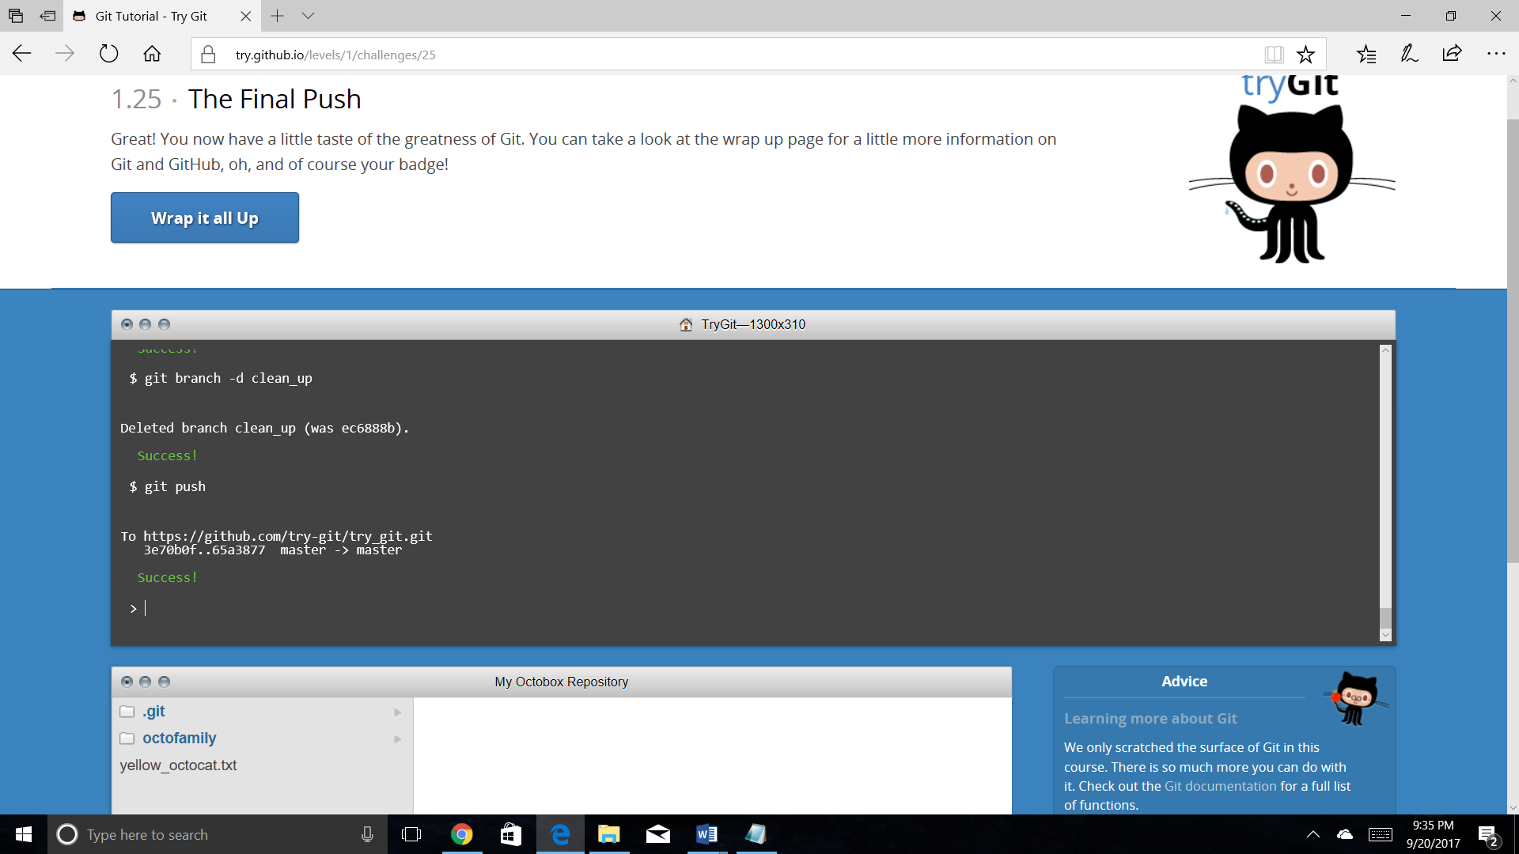

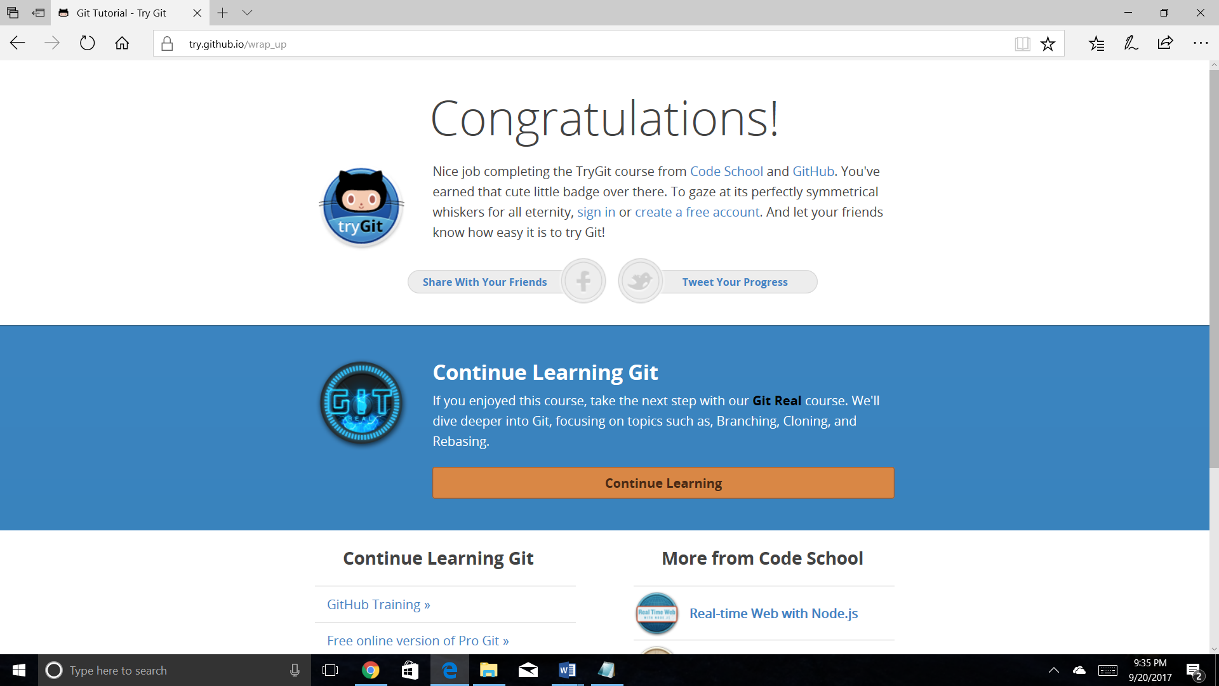

Steps involved retrieving the README.md file

1. Use the link <https://github.com/paceuniversity/courses>.
2. Click on fork
3. Click on edit
4. Edit the file
5. Commit